**AgroTech**

**Problem Statement**: To have maximum yield, there is a need for optimum irrigation. The need for water depends on various parameters like soil moisture, water level, weather condition etc. Currently, irrigation happens based on human inspection and does not take into account various parameters which make it optimal. The above mentioned parameters can be measured and well used in optimizing water delivery as well as biological macro-nutrients in some form. Using historical/agricultural data helps further in providing real-time irrigation requirement by ensuring optimal usage of water to get the improved yield.

**Objectives:**

--> To improve the yield by optimizing the usage of water in the fields

--> To recommend the macro-nutrients requirement to the farmer by real-time monitoring of soil parameters

**Introduction:**

**Sensor Data Collection**: Sensor Module will sense soil moisture, Macro -nutrients (NPK) at regular intervals.

**Communication**: The data collected by sensor module will be transmitted wirelessly to Raspberry Pi (System on Chip) through ESP8266 NodeMCU.

**Data Analytics**: Analysis will be done on the collected data from the senor module and the weather forecast.

**Action:** Farmer will be notified and the system will control water delivery automatically.

**Optical sensors** are used to measure the macro -nutrients (NPK values).

**Raspberry Pi** processes the aggregated values from the multiple sensor nodes.

**Machine learning** model will be used to analyse the data from the sensor module and generate recommendations for the optimized yield.

**Internet connectivity** will be used for communication with the cloud server.

**Methodology:**

The proposed smart irrigation system collects data regularly from various fields using sensors connected to the sensor node. The edge gateway collects the data from several sensor nodes & sends it to the fog node for further processing. The fog node applies intelligent algorithm on collected data and weather forecast then sends instruction accordingly to the actuator node to control the water delivery system.

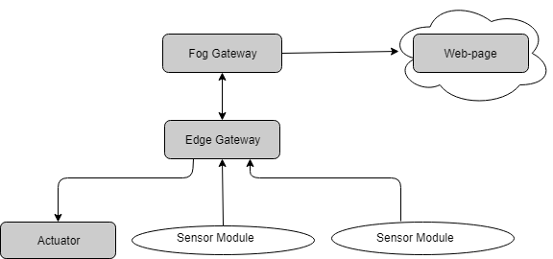

Figure 1: Above shows the proposed architecture of our smart agricultural system.

**Design and implementation**: This section explains about the various hardware and software components used in implementing the system.

**Hardware:** Raspberry pie controllers, Arduino boards, NodeMCU, sensors like (NPK sensor), water level sensor, soil moisture sensor.

**Communication protocols:** SPI (Serial Peripheral Interface), MQTT (Message Queuing Telemetry Transport) and Wi-Fi.

The following figure shows various Hardware Components & Communication protocols used in the implementation the system:

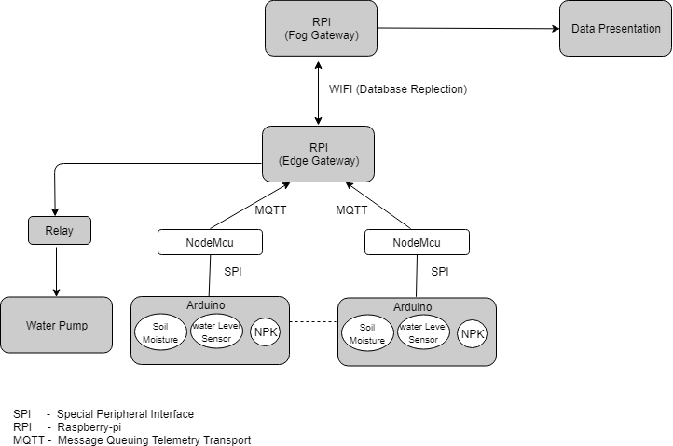

Figure 2: Communication Protocol.

As shown in the figure, at the lower level we have several sensors (like SM, WL and NPK) and Actuators (water delivery system) connected to the Arduino board.

We have used Arduino board to collect the values from the sensors (SM, WL and NPK). The Arduino board uses SPI protocol to communicate with the NodeMCU. In our design, we have used MQTT communication protocol for data transfer between Arduino & RPI. The MQTT protocol is a communication protocol which is based on Pub-Sub model.

The data will be aggregated at the Edge gateway in MySQL from multiple sensors nodes. In our Implementation, we have used MySQL database replication to send the sensor data from edge gateway to the fog gateway.

**Challenges and Resolution:**

At first we designed a system that was working very efficient on paper but when we started the implementations, real problems were encountered.

* **Problem**: The first problem faced, when we required data for machine learning algorithm. We thought to do farming in small field for data generation but situations were not in our favour, then we met with many universities like Agricultural University, IIIT Hyderabad and CRIDA but from everywhere we returned empty handed. After investing too much time for data, we felt it is better to create dummy data.

**Solution:** So we decided to prepare the small synthetic data and work on it.

* **Problem**: For Macro-nutrients recommendation, we required the health status of multiple soil samples. So we started to search for a readymade sensor which can detect the value of macro-nutrients but such type of a sensor does not exist in our Indian market. Although few sensors are available in the international market but they are way too costly (Rs. 6000 approx.) which defies the purpose of our project.

**Solution**: So our Enthusiastic team got an idea to prepare a NPK sensor on their own at cheap cost. We had gone through many research papers and selected one of them to work on. After brainstorming, we got the basic idea of developing the NPK sensor (optical sensor).Later we prepared the sensor but the main bottleneck was the calibration of the NPK sensor. To move ahead, we needed the complete report of some specific soil samples (Nitrogen rich, Phosphorus rich and Potassium rich). After meeting with horticulture department of our university we got some soil samples. But we did not get the soil health report. As of now we are simply developing the prototype of NPK sensor with assumed values for calibration since developing a sensor could be another project.

* **Problem:** When we started working with NodeMCU (Micro controller) we found that there is only one analog pin which was not enough to collect the multi parameters of soil.

**Solution:** We integrated the NodeMCU with Arduino so that we can have more analog pins for data collection.

* In the first scenario we were using only one Raspberry Pi for data gathering but after discussing with Dr. Nagender Kumar S as per his suggestions, to make the system novel and balance the load, we integrated one more Raspberry Pi. While trying to establish a stable connection we faced lot of problems with static-IP. Eventually we succeeded to achieve the milestone. Now we are able to replicate the database from edge node to fog Node.
* As of now we are not able to integrate the GSM Module with Raspberry Pi so we changed our approach and created local network of our devices using a router.

For internet connectivity, we are using the wireless-LAN so that we can test whether our system is performing up to our expectation or not.

After preparing the working model, we will definitely try to integrate the GSM Module so that our system can work autonomously.

* As we are short of time and system is not giving the desired output, sometime it behaves very random and we are stuck to solve those problems so we are removing the overhead of Android app. We felt that for proof of concept we don’t need to the Android app so we are developing a web page to present the facts of soil health and water requirement.

**Learning Outcomes**:

* Integration of several sensors/modules.
* Establish reliable communication using different protocols.
* Achieved working knowledge of multiple sensors as well as the NPK sensors.

**References**:

1. Detection of nitrogen, phosphorus, and potassium (NPK) nutrients of soil using optical transducer

Publisher: IEEE

<https://ieeexplore.ieee.org/document/8312001>

1. Raspberry Pi Guide:

<https://www.raspberrypi.org/help/quick-start-guide/2/>

1. Getting Started with Arduino and Genuino UNO

<https://www.arduino.cc/en/Guide/ArduinoUno>

**ACKNOWLEDGEMENT:**

*We would like to express our thanks of gratitude to our guide Dr. Nagender Kumar S as well as Mentor Dr. K Swarupa Rani who gave us the golden opportunity to do this wonderful project*

*Secondly we would also like to thank to our DEAN Dr. K. Narayana Murthy and Pro- Vice-Chancellor – 1 Dr. Arun Agrawal for providing all the facility that we require.*